All cases are using 5V power supply as battery voltage.

The circuit is soldered onto prototyping board with large size connector for high current.

Yellow trace is channel 1 while green trace is channel 2

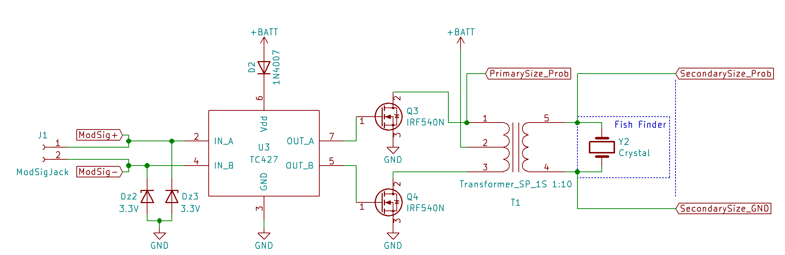

This is the driving circuit diagram with transformer probing position labeled.

1. Transistor with no load connected at 200Khz

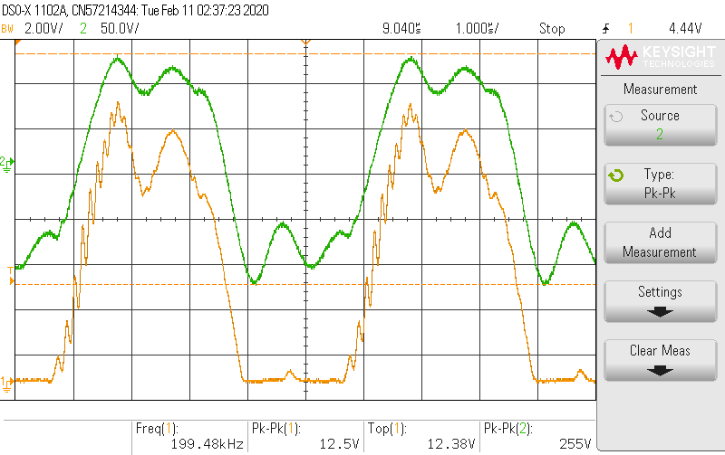

Transistor primary side vs secondary side, channel 1 for primary, channel 2 for secondary

The output voltage seems right, however, there are some big ripples.

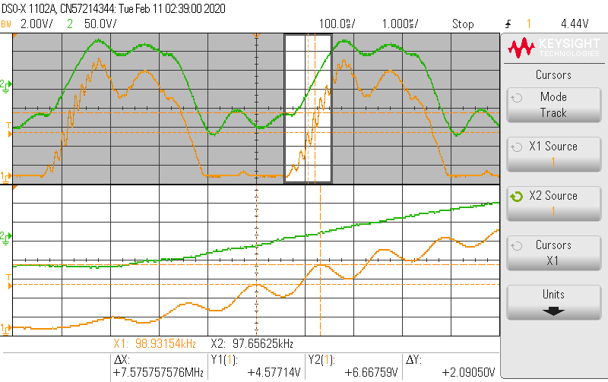

Transistor primary side vs secondary side zoom in on the rising edge ripples at 7.5Mhz.

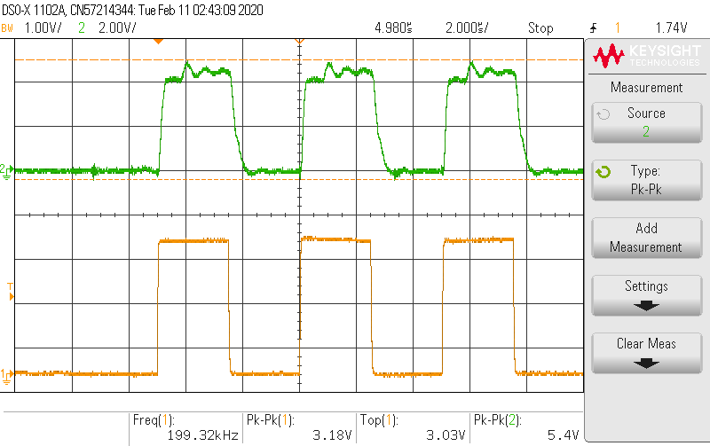

Channel 1 is microcontroller input to gate driver; Channel 2 is gate driver output.

There seems to be some ripple on the high pulse.

1. Transformer with a 10Kohm load, at 200Khz

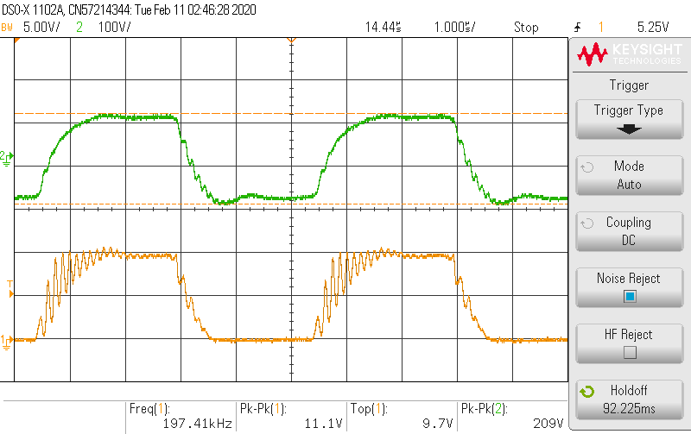

Same channel setup, channel 1 is primary side, channel 2 is secondary side.

The High side ripple is smoothed out. Instead there are much more 7.5Mhz ring.

1. Transformer with fish finder at 200Khz

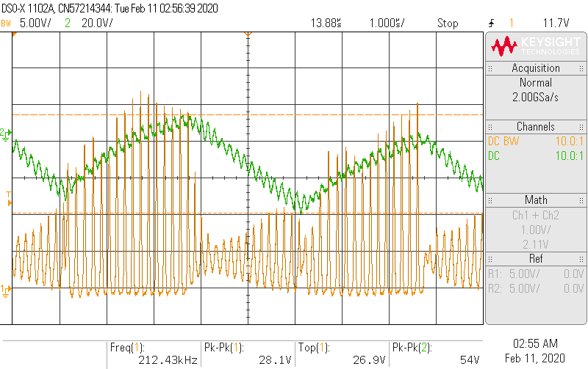

CH1 for primary, CH2 for secondary.

The primary side now doesn’t even reach a steady 10V (5V\*2 due to center tap). Also, during the second when it suppose to pull down, the waveform still shows a high amplitude signals.

Secondary side seems heavily loaded.

When zoomed in, the high frequency peaks are still at around 7Mhz.

1. Fish finder tx rx pair.

Channel 1 is connected to the transmitting fish finder, Channel 2 connected to the receiving fish finder which is sitting right next to it in a small bucket of water.

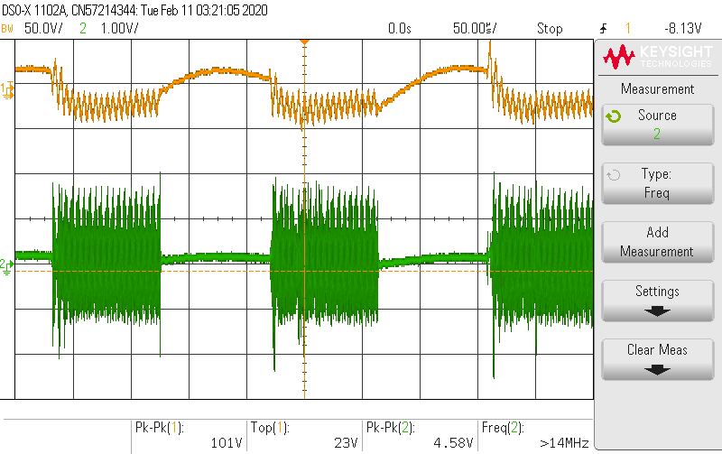

Fish finder transmitting 1010101010 bit patten.

From channel 2, the on and off segments has big difference in amplitude.

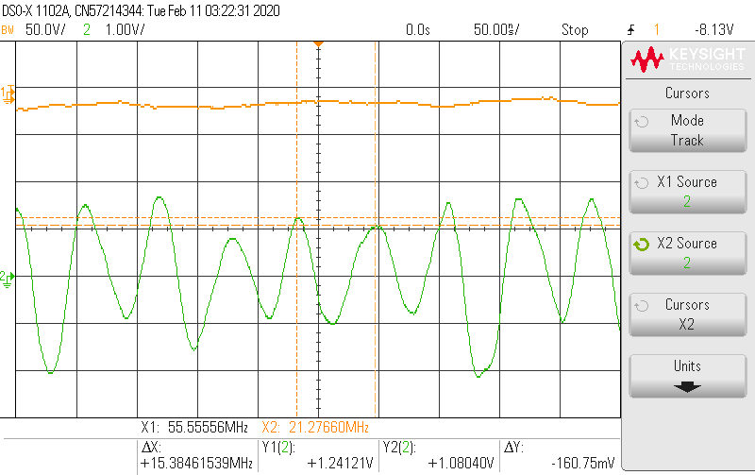

Fish finder tx rx, on-segment zoom in

During the high bit, the receiving fish finder has a obvious 15Mhz component. It is unclear if the 200Khz is still there or not.

1. Transformer with fish finder at 80Khz

When attempting to measure the impedance of fish finder, it is found that usually current is leading the voltage. However, the phase reach zero at 80Khz and reverse slightly around 78Khz.

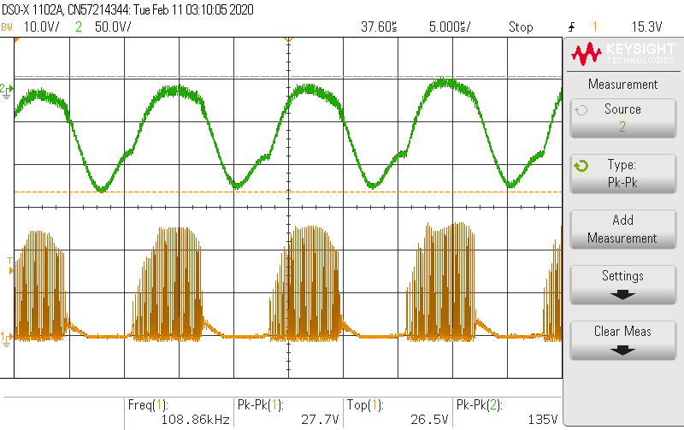

Channel 1 is primary side of transformer and channel 2 is secondary side.

The pulse is similar on the pull up half while cleaner on the pull down half.

Channel 2 seems to be better than 200Khz case.